New Warehouse Safety Start-Up Standard Operating Procedure_
The purpose of this standard operating procedure is to outline the safety procedures for a new warehouse start up.
  - Step 1: Supplies.
- Permit of Occupancy.
- Laminator, and laminator sheets. (Safety will carry with them)
- 1” 3 ring binders (1 for each picker and forklift).
- Dock chains.
- Safety signs and banners.
- Eye wash station kit.
- First-Aid kit.
- OSHA labor law poster.
- Evacuation map.
- Smoke and carbon monoxide detectors.
- Wheel chocks.
- Hooks and hardware for PPE inspection and storage station.
- We are K&M board.
- 24” x 36” cork boards.
- Safety Data Sheet ( SDS ) binder and mounting basket.
- Emergency phone numbers.
- Emergency weather shelter sign.
  - Step 2: Procedures.
- Acquire the permit of occupancy from the facilities department. Laminate the document and post up in or near the main office.
- Label each 1” three ring binder for each picker and forklift that will be kept on site. Inside each binder place corresponding picker or forklift inspection sheets which can be found at F:\warehouse\shared\forklift and picker info.
- Install dock chains on all dock bay doors. Dock chains can be found at suppliers such as: Home Depot, Tractor Supply, etc., locally, or ordered for delivery through Amazon.
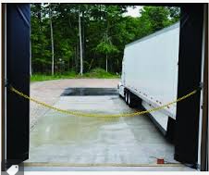
- Hang up safety banners in breakrooms, near the time clock, and other high traffic areas. Various safety banners can be ordered for delivery through Amazon.
- Hang and install the eye wash station. For the eye wash station, the Safety Department will order and send to the Warehouse. The Safety Department will also order new eyewash stations annually for each site.

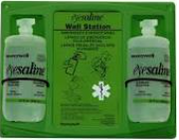
- Hang up the first-aid kit in an easily accessible area for the employees. Purchase a wall hung ANSI/OSHA compliant first-aid kit through Amazon for delivery. K&M Tire will supply the restocking materials when needed.
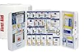
- Hang up the OSHA labor law poster in the breakroom, or near the We Are K&M Board. This item will be sent to the location by the K&M HR Department.
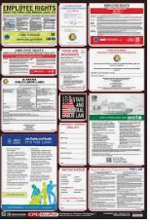
- Laminate and post evacuation map at high traffic areas. The building layout map can be found at F:\security\shared\locations\building layout. Notate on the map all exit doors, current location, fire extinguishers, emergency weather safe shelter, and rally point outside.
- Hang smoke and carbon monoxide detectors in all offices, and breakrooms. Purchase these at a local Walmart, Home Depot, Lowes, etc.
- Ensure that there is at least one wheel chock for each bay door. These can be ordered for delivery from Amazon.
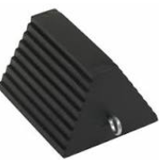
- Make sure the K&M board is properly supplied and hung up. The K&M board will be supplied by the training department, verify this ahead of time.

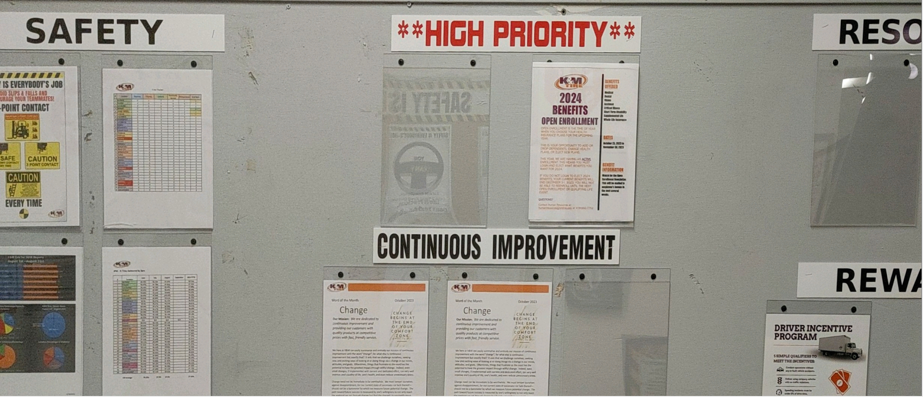

- Prepare and install PPE inspection and storage area in the warehouse. All the needed hardware can be purchased at Walmart, Home Depot, Lowes, Tractor Supply, etc.
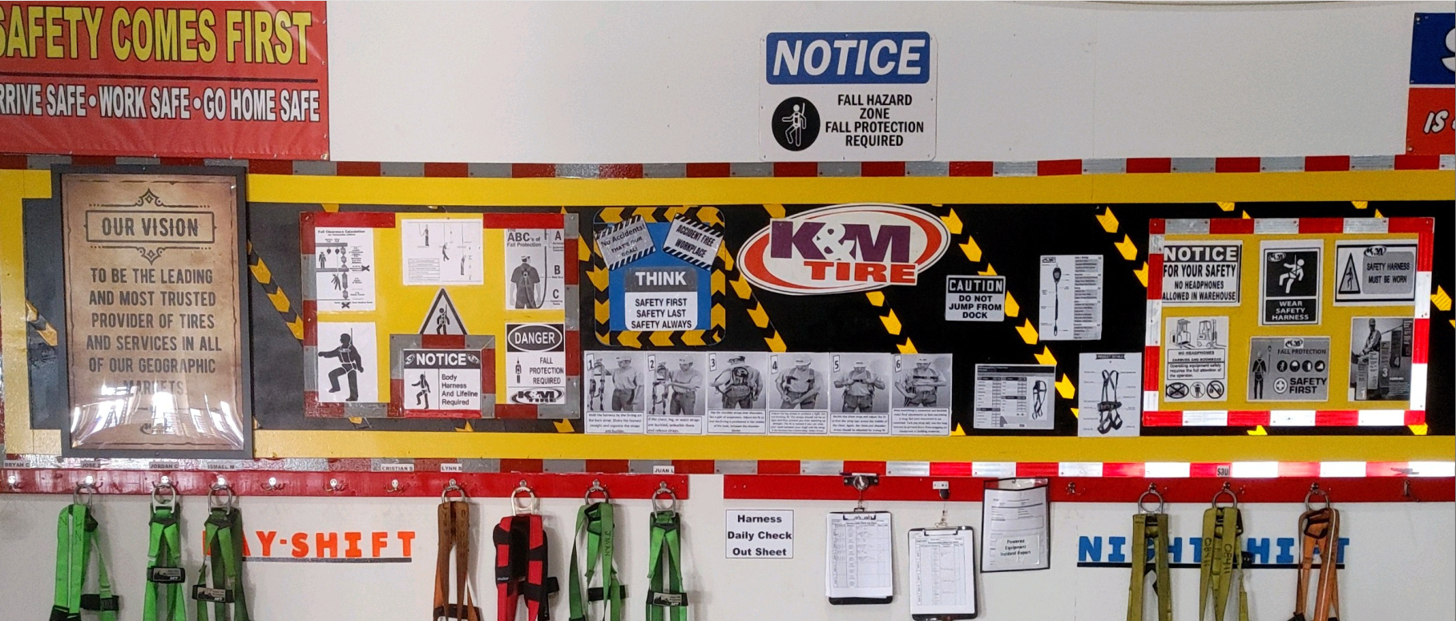
- Ensure Safety Data Sheet ( SDS ) binder is updated and hung up for easy access for all employees. Purchase this item for delivery through Amazon.
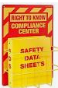
- Document all emergency phone numbers i.e., 911, non-emergency number for the police department, fire department, local hospital, the company that services the fire suppression system, the company that monitors the alarm system, the water department, if the warehouse uses natural gas, the gas company, the company that supplies propane, the R.O.M.’s number, and the warehouse manager. Laminate this document and post up in the main office and the breakroom.
- Designate and post up a sign for the emergency weather shelter room ( usually a restroom inside the building. This can be purchased either at local vendors such as Walmart, Home Depot, etc. It can also be purchased for delivery through Amazon.

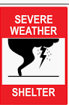
- It is important to note that you will need to confirm the correct mailing address of the new location for Amazon delivery purchases well ahead of your arrival time, and schedule these deliveries to coincide with your presence at the location.
  - Step 3: Annual Inspections.
These items will be inspected for compliance by the safety department during annual site safety inspections.

